Juan Pablo Aschner Rosselli

Universidad de los Andes

**Germán Samper (1924--)**

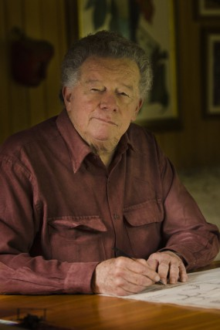

Germán Samper

<http://www.germansamper.com/images/galerias/fotografias/retratos_nigaleano/vsig_images/_NIC5193_285_428_90.jpg>

Germán Samper Gnecco was born in Bogota, Colombia on April 18, 1924. He studied architecture at the National University of Colombia. Shortly after finishing his career in 1947, he joined the workshop of Le Corbusier in Paris where he worked until 1954 on projects such as Bogota’s Master Plan, the Court of Justice, the Palace of Ministries and the urban plan of Chandigarh, India, among others. On his return to Colombia and deeply influenced by Le Corbusier, he worked as an independent architect until he joined, in 1958, the firm Esguerra Saenz Urdaneta Suarez, where he became partner and design director. For forty years he designed and directed the construction of several projects in Bogota, Colombia such as the Luis Angel Arango Library (1957), the Gold Museum (winner of the National Architecture Prize in 1970), the Avianca building (1968), the Banco de Occidente Building (1984), the Colsubsidio Citadel (1990) and Cartagena’s Convention Center (1979).

During this period and in parallel, he began an investigation on self-construction, progressive development and productive housing and on urban development and public space in Latin American cities. As a result of this research is a set of books of his authorship published by Editorial Escala and the implementation of his reflections in such projects as the popular neighborhood housing proyect of La Fragua in Bogotá, an initiative that was built by a community of low-income families between 1958 and 1961. Other housing projects followed such as Carimagua (1968), a proposal for PREVI (a large scale International Competition on Experimental Housing for Lima, Peru, 1969) and the Ciudadela Real de Minas in Bucaramanga, Colombia (1977), among others.

Germán Samper has devoted several years of his life to teaching. Between 1956 and 1959 he was Dean and Professor at the Faculty of Architecture of the Universidad de los Andes. In 1970 he was Visiting Professor of the course "Industrialization and Housing" at the CINVA (Center for Inter-American Housing). Since then he has taught several workshops in latinamerican architecture faculties.

Another notable aspect of his career are his sketchbooks and project drawings. Starting with his arrival to Le Corbusier’s workshop and uninterruptedly since then, he has made sketches and drawings on each and every journey undertaken and project developed.

The buildings that Germán Samper developed with Samper Esguerra Saenz and are now landmarks in the civic and public landscapes of Colombia’s major cities and are also representative examples of the Colombia’s modern movement. Buildings that due to their economy and strict use of architectural elements, exalt the value of simplicity.

In 1995 he founded together with his daughter Ximena, GX Samper Architects Ltd., firm with which he is currently working. Since then the development of their projects transmits a progressive detachment of the modern rationalism that characterized his early work. They propose, in opposition to the isolated buildings that characterised modernity, a return to the development of neighborhoods made of contiguous and continuous housing, architecture where pedestrians and automobiles coexist, urban areas that exalt public life and that offer humane alternatives in the consolidation of cities. Residential projects are thus thought as to improve community life and promote social integration and solidarity, aspects that characterize Samper’s built legacy and that are a significant contribution to the present thinking and making of collective and residential spaces in Colombian cities.

**List of selected works**

With Esguerra, Sáenz and Samper

1956 Sena building, Bogota, Colombia

1956 Carmel Country Club. Bogota, Colombia

1956-1961 Luis Ángel Arango Library, Bogota, Colombia (first and second stage)

1958 La Fragua, self-building housing, Bogota, Colombia (With Yolanda Martínez de Samper)

1963 Gold Museum, Bogota, Colombia (first stage)

1965 BCH building, Bogota, Colombia

1967 Pan American Life Insurance building, Bogota, Colombia

1968 Administrative Centre for the Municipality of Cali, Colombia (With Ricaurte Carrizosa Prieto)

1968 Avianca building, Bogota, Colombia (With Ricaurte Carrizosa Prieto)

1968 Carimagua neighborhood, Bogota, Colombia

1968 Sidauto neighborhood, Bogota, Colombia

1969 Experimental Housing Project (PREVI), Lima, Peru

1970 La Alhambra neighborhood, Bogota, Colombia

1970 Coltejer building, Medellin, Colombia (With Fajardo Vélez Ltd. and Jorge Manjarrés)

1971 Irotama Hotel, Santa Marta, Colombia (First and second stage)

1972 Santa Anita neighborhood, Quito, Ecuador (With Banderas Vela Arquitectos)

1972 Tibaná – Intervil neighborhood, Bogota, Colombia

1973 Engineering Laboratories, El Valle University, Cali, Colombia

1974 Banco Popular building, Medellín, Colombia

1979 Real de Minas Citadel, Plaza Mayor and Los Naranjos neighborhood, Bucaramanga, Colombia

1979 Colseguros competition, Bogota, Colombia

1979 Convention Centre of Cartagena, Colombia (With Taller de la Ciudad. Eduardo Samper and Carlos Hernández)

1981 El Tiempo building, Bogota, Colombia (With Cristian de Groote)

1981 Financiera de Valores Seguros Andina building, Bogota, Colombia

1981 Ciudad Guasare, Maracaibo, Venezuela

1981 Calle 100 Residential Complex (CVM), Bogota, Colombia

1984 Banco de la República, Barranquilla, Colombia

1985 Banco de Occidente building, Bogota, Colombia

1980 El Universo Newspaper, Guayaquil, Ecuador (First and second stage)

1985 Las Brujas housing cluster, Medellín, Colombia

1985 -1990 Colsubsidio Citadel Master Plan, Bogota, Colombia

G.X. Samper Architects

1995-2011 Colsubsidio Housing Blocks, Bogota, Colombia

1995-1996 Ciudad Meléndez, Cali, Colombia (With Raúl Ortiz)

1995-1997 Los Hayuelos neighborhood, Bogota, Colombia (With Economistas Urbanos, Mario Noriega and Miguel Télllez)

2001-2006 Tierragrata neighborhood, Bogota, Colombia

2007-2008 Las Mercedes – Icarus neighborhood, Bogota, Colombia

**References and further reading**

Angel, M.; Arias, F.; Aschner, J.P.; Campuzano, C.; Cortés, R.; Daza, R.; Doshi, B.; Jiménez, F.; Martínez, Y.; O’Byrne, M.C.; de Ory, J.A.; Samper, E.; Samper, X.; Tellez, M.: Topelson, S.; Vargas, H.; (2011) *German Samper*, Bogota: Diego Samper Ediciones.

Samper, G. (2003) *La Evolución de la Vivienda,* Bogota: Editorial Escala.

Samper, G. (1994) *El Recinto Urbano, la Humanización de la Ciudad,* Bogota: Editorial Escala.

Samper, G. (1986) *La Arquitectura y la Ciudad, Apuntes de Viaje,* Bogota: Editorial Escala.

**Visual material:**

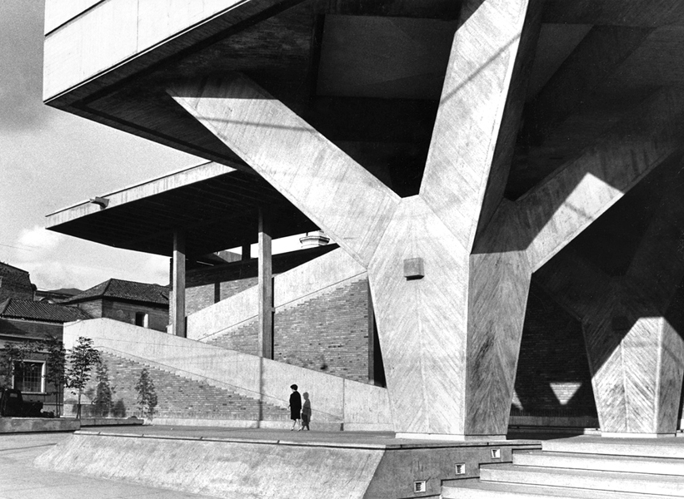

1956 Sena building, Bogota, Colombia

<http://www.revistaaxxis.com.co/file/Galeria/SENA_foto_Germ__n_Tellez.jpg>

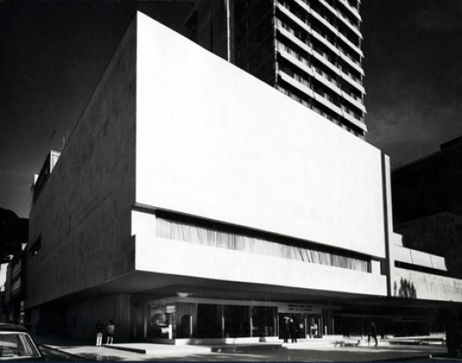

1963 Gold Museum, Bogota, Colombia (first stage)

<http://www.germansamper.com/images/galerias/fotografias/seleccion/vsig_images/museodeloro07_545_428_90.jpg>

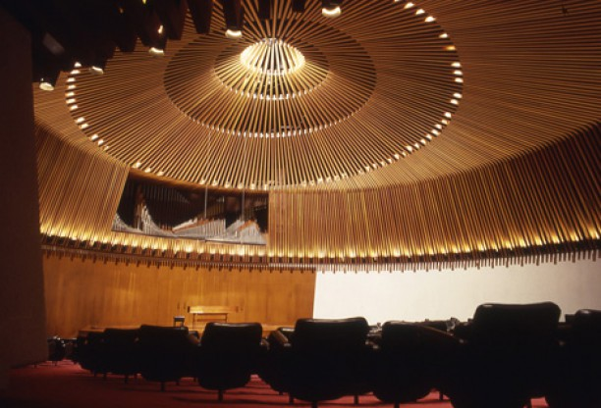

1956-1961 Luis Ángel Arango Library, Bogota, Colombia (first and second stage)

<http://www.germansamper.com/images/galerias/fotografias/seleccion/vsig_images/bibliotecaluisangelarango01_612_416_90.jpg>